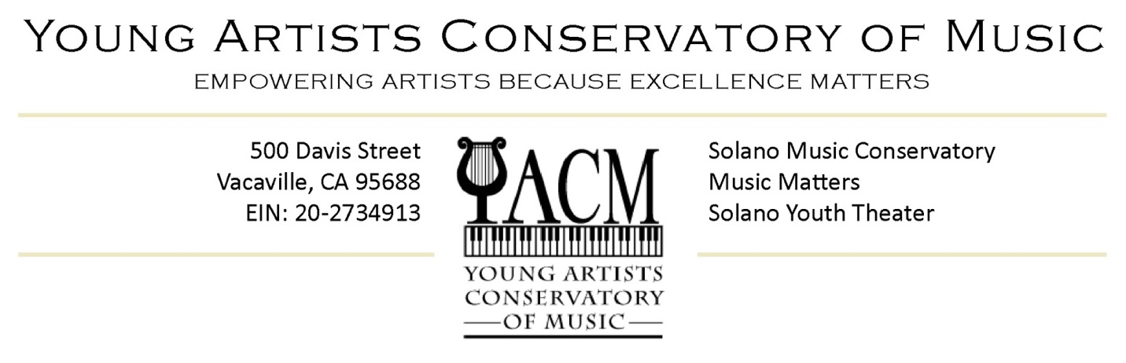
Press Release
February 4, 2017

Contact
Wanda Cook / wcook@youngartistsconservatory.org
707.718.7775

Evan Losoya (18) Vacaville rising pianist, composer, and student at the Young Artists Conservatory of Music (YACM), will perform the allegro movement from Haydn’s Piano Concerto No. 11 in D Major with the Solano Symphony Orchestra as a winner of their Salute to Youth Competition.

Losoya will perform Saturday February 11th at 8:00 at Downtown Theatre in Fairfield and Sunday February 12th at 3:00 pm at Vacaville Performing Arts Theatre. The Solano Symphony’s Salute to Youth Competition is an annual competition that awards winning young musicians in Solano County the opportunity to perform a classical concerto with a symphony.

Wanda Cook, founder and director of Young Artists Conservatory of Music and Evan’s piano instructor of five years praises his ability: "Evan projects a serene elegance and proficient execution with dynamic engagement for his listeners. As his piano instructor, I enjoy his proficient and fresh expression of Haydn’s work, while respecting the creative intent of the composer. I encourage families with young people studying piano to attend the concert. Evan is sure to inspire them to pursue their potential."

Evan Losoya:
“Lately my preferences for piano works lie in the contemporary works of Russian composers like Shostakovich, Prokovief and Bartok. A year ago, I attended the San Francisco Symphony featuring Yuga Wang performing Bartok’s 2nd piano concerto. It was my first significant exposure to Bartok and the performance changed my life. I later practiced and performed a Shostakovich Concerto and feel as if I gave grown musically more than ever. A few months ago I was faced with choosing a concerto for the Solano Orchestra Symphony competition. In choosing Haydn, I decided to affirm my familial early classical roots. It is a fresh, and immensely happy movement. I hope I will be an inspiration to young people who would attend the concert in much the same way Bartok and Yuga Wang inspired me. I am grateful to The Solano Symphony Orchestra for the opportunity to perform with them”.
Losoya maintains an impressive musical resumé. In addition to being an accomplished pianist, Evan is an oboist who has occupied first chair with the Northern California Honor Band three years in a row. He has received numerous musicianship awards in associations with Jazz Festivals throughout the region. He was named Featured Pianist (a highly-prized and prestigious distinction) at the Young Artists Conservatory of Music for the 2015-16 and 2016-17 seasons. At YACM’s Black Tie Gala Concert (June 2016) Losoya delivered a masterful performance of Dimitri Shostakovich’s Piano Concerto No. 2 with the SONUS Symphony conducted by Dr. Stephen Thompson. He is also a published composer, having recently compiled his first collection of works in his book “At the Moment,” which he debuted at the Steinway and Sons Piano Gallery in Walnut Creek this past fall. In November 2016, Losoya
was awarded 2nd place at the MTNA Northern California Senior Composer Competition for his original Rhapsody entitled “Hypnotic Suggestion”.

While preparing to perform with the Solano Symphony this weekend, Evan is also preparing to perform Bela Bartok’s Piano Concerto No. 3 at YACM’s upcoming Black Tie Gala Concert Sunday June 4th which will be held at the Vacaville Performing Arts Theatre. Losoya is a graduating senior at Vacaville Christian School where he and is heavily involved in Jazz band. undergoing college auditions and interviews to pursue a degree in music composition.

Young Artists Conservatory of Music is a non-profit youth development organization that empowers young people through excellence in the musical arts. Our mission is to help youth develop the skills to recognize and unlock their potential in life and in the arts. We believe in taking responsibility for the things our young people see, hear, and do. By doing this we and our members are exercising leadership for shaping the culture that inspires our community.

